# Problem 1:

1. Yes, the four tables satisfy k-anonymity. GT[0,1], weakly achieves it.
   1. GT[1,0] has a k of 1
   2. GT[1,1] has a k of 2
   3. GT[0,2] has a k of 2
   4. GT[0,1] has a k of 1

The least minimization is found in tables GT[1,0] and GT[0,1]. This is because the zip has not been anonymized for GT[1,0], while the race has been generalized to level 1 anonymization. In GT[0, 1], the situation is reversed: zip has been anonymized to level 1 anonymization, but race has not.

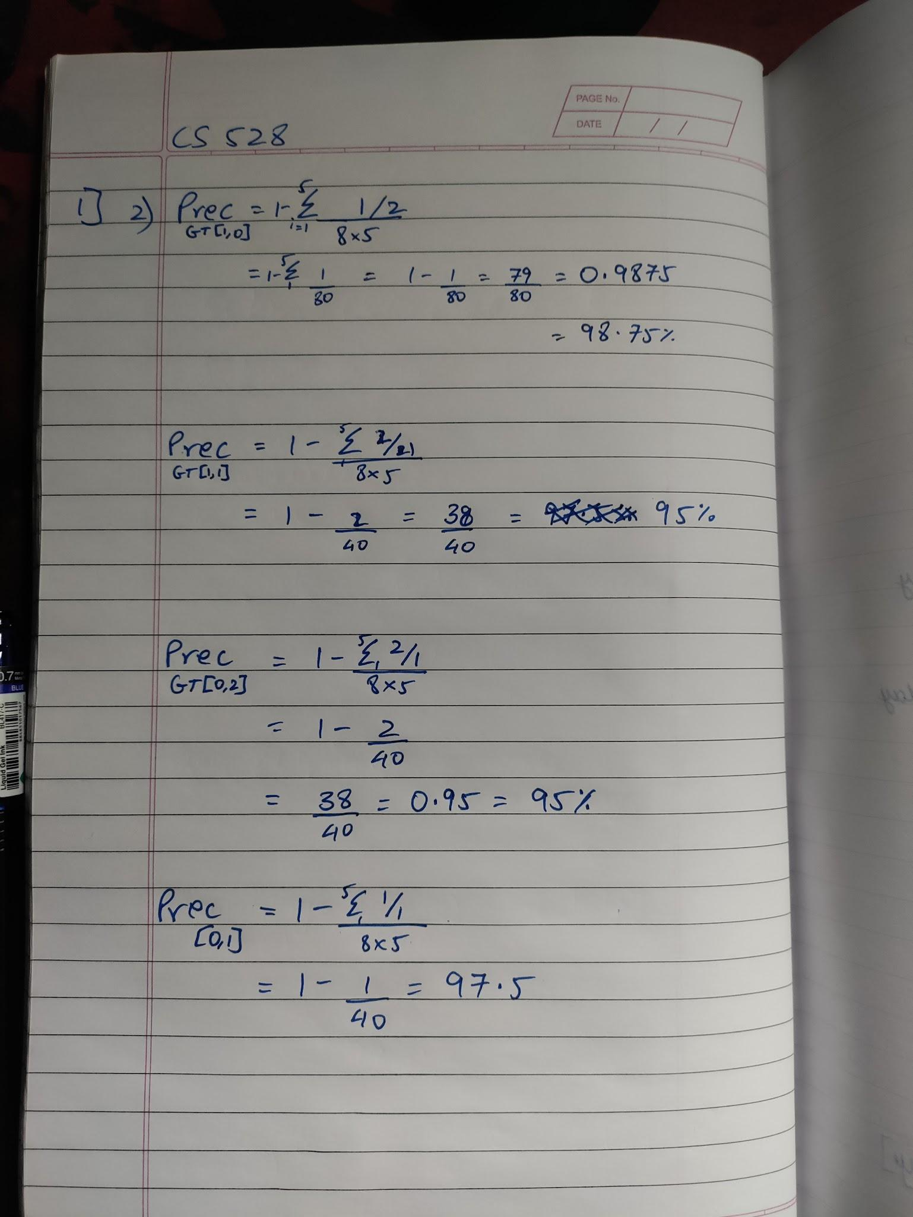

| **Race** | **BirthDate** | **Gender** | **ZIP** | **Problem** |
| --- | --- | --- | --- | --- |
| Person | 1965 | male | 021** | Lungs |
| Person | 1965 | male | 021** | Chest |
| Person | 1965 | female | 021** | Eye |
| Person | 1965 | female | 021** | Lungs |
| Person | 1964 | female | 021** | Weight |
| Person | 1964 | female | 021** | Chest |
| Person | 1964 | male | 021** | Lungs |
| Person | 1965 | female | 021** | Mind |
| Person | 1964 | male | 021** | Weight |
| white | 1964 | male | 021** | Head |
| white | 1967 | male | 021** | Stomach |
| white | 1967 | male | 021** | Back |

# Problem 2:

## Step 1:

Graph 1:

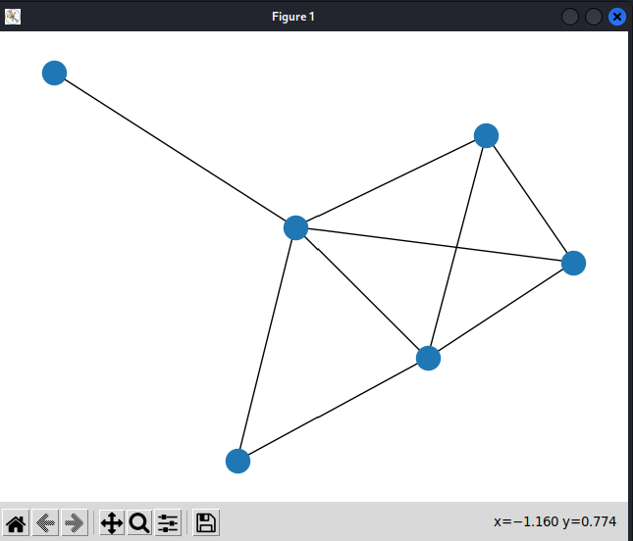

Graph 2:

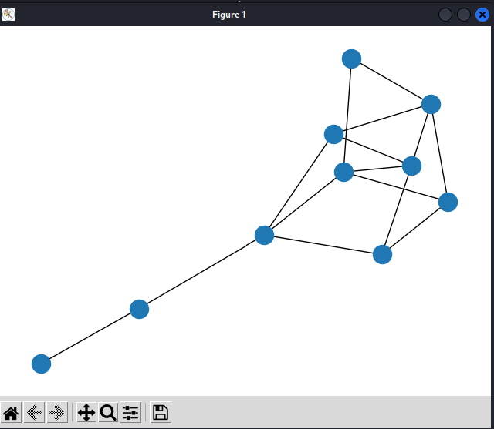

Graph 3:

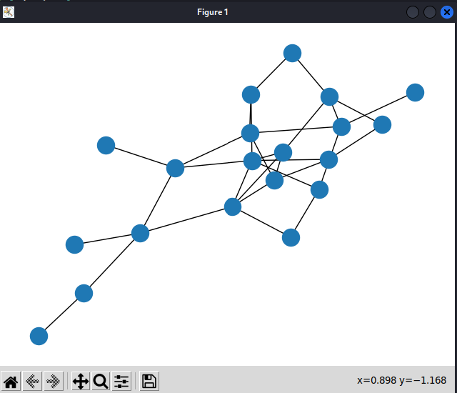

The code used to generate the graphs:

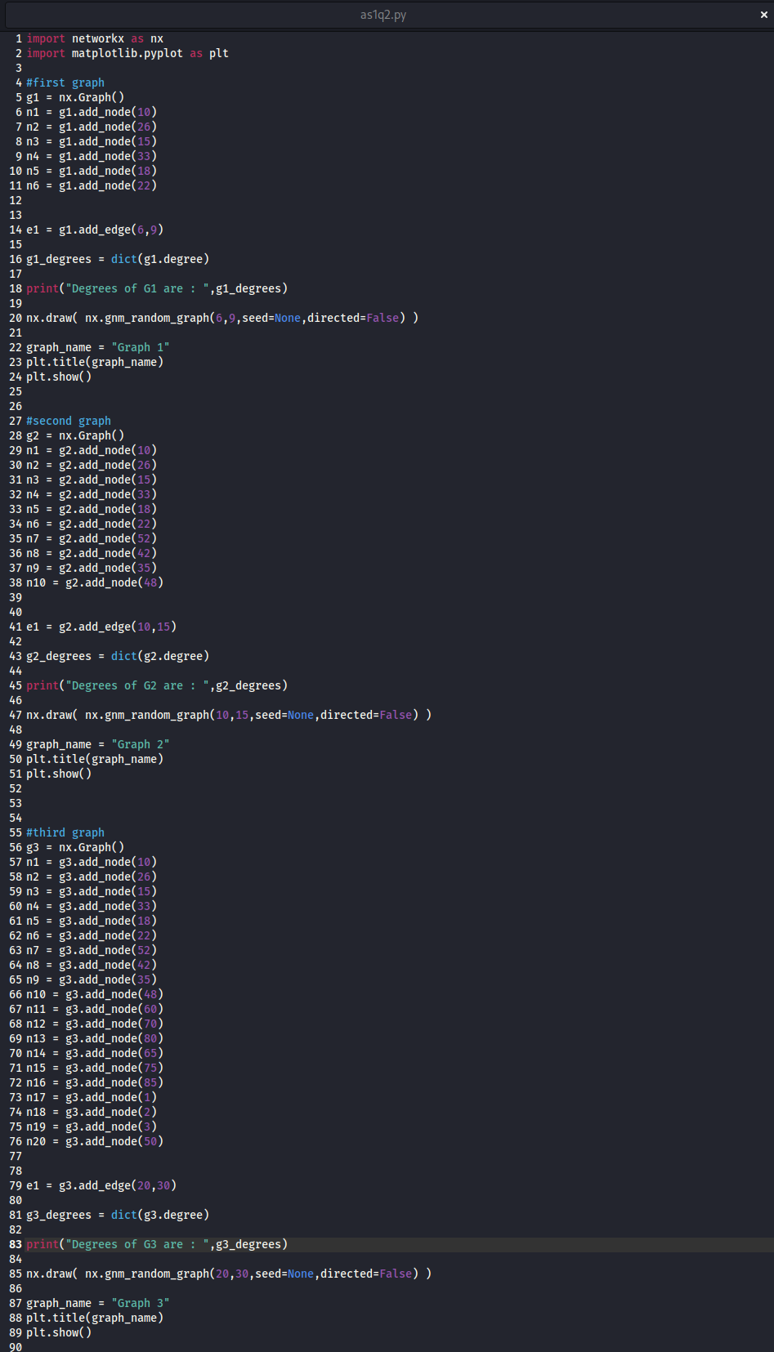

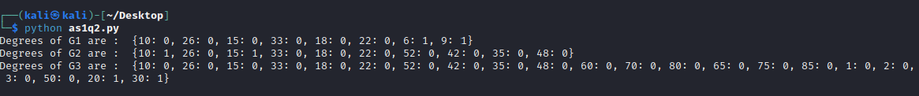

Here we see the degrees of each graph printed.

## Step 2:

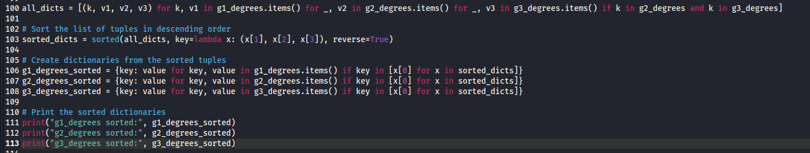

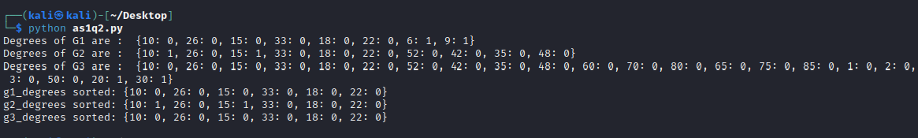

## Step 3:

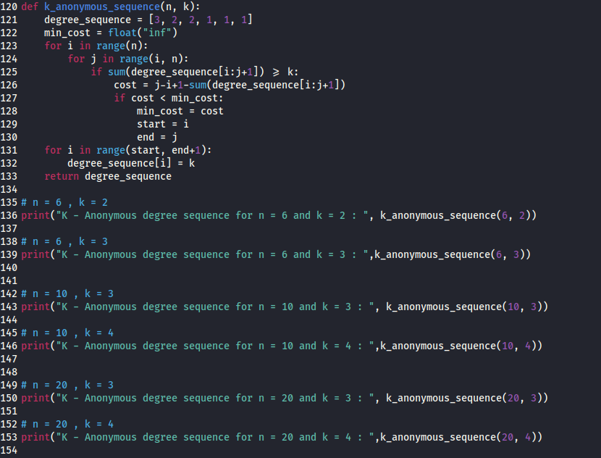

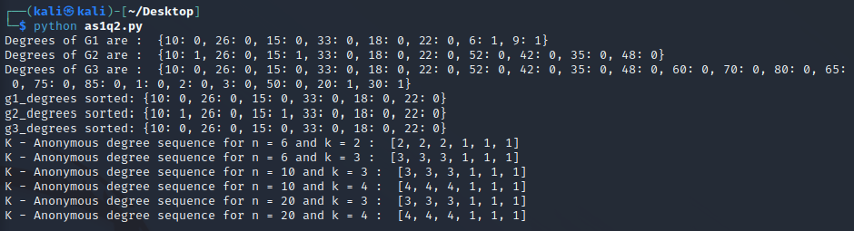

## Step 4:



The degree sequence d are not always reliable for determining the degree distribution of a graph. This is because the degree sequence only represents the number of edges connecting to each node but does not provide information about the specific arrangement of these edges in the graph. As a result, there may be multiple different graphs with the same degree sequence but different structures. So, the degree sequence isn't the only way to find out how the degrees are spread out in a graph, and it doesn't mean that the degree distribution is unique.

The entire code for Problem 2:



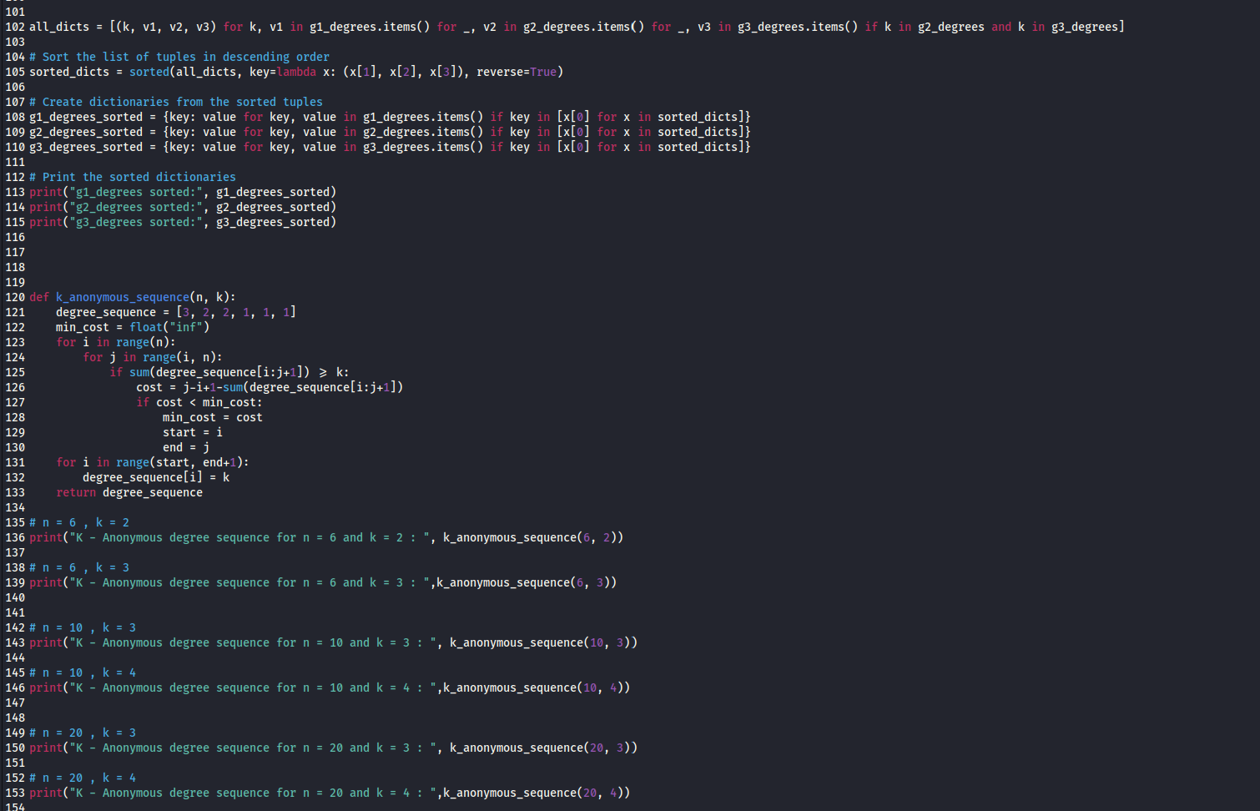

# Problem 3:

1. For the attribute "age", a possible generalization hierarchy could be
2. <18
3. 18-25
4. 26-35
5. 36-45
6. 46-55
7. 55

For the attribute "education", a possible generalization hierarchy could be

1. Bachelors
2. Masters
3. Doctorate
4. Other

For the attribute "marital status", a possible generalization hierarchy could be

1. Married
2. Never-married
3. Divorced
4. Separated
5. Widowed
6. Married-spouse-absent
7. Married-AF-spouse

For the attribute "race", a possible generalization hierarchy could be

1. White
2. Other

b)

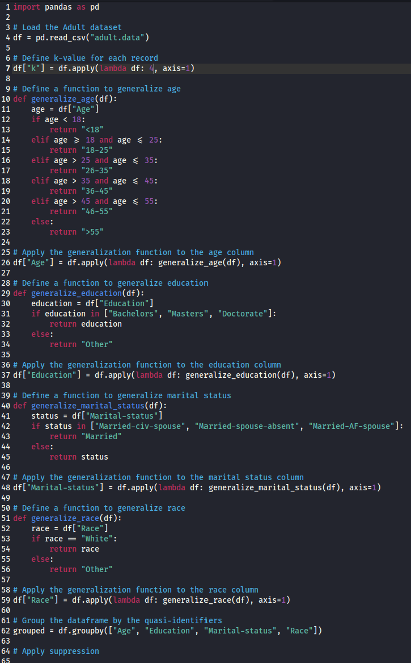

c)

